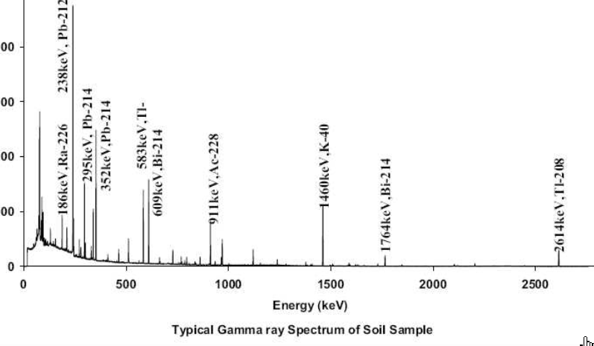
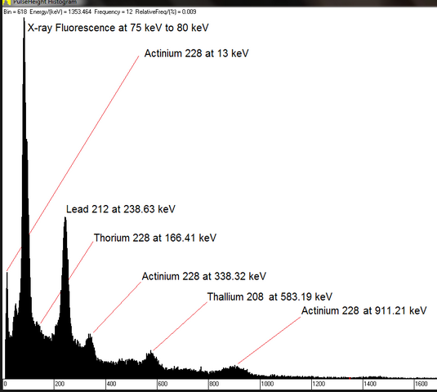
99.3% of all naturally occurring U is U-238; U-238 series has lots of gammas >~250 keV while other series don’t; about 2000 Bq =54,000 pCi of Ra-226 in our bodies 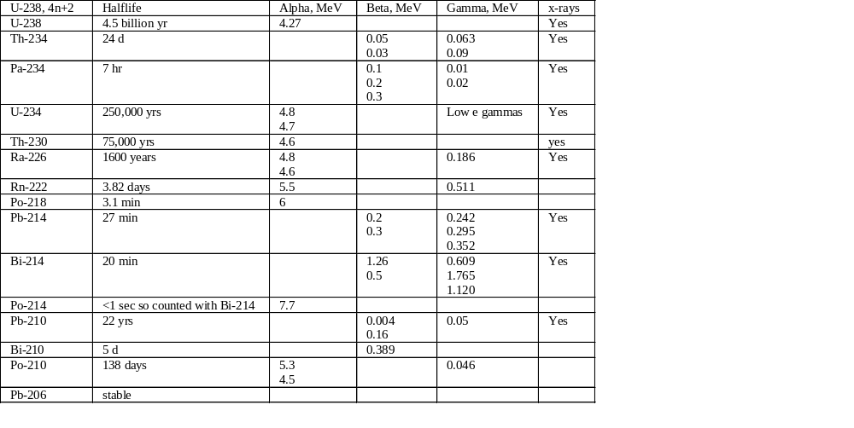
Th-232, 4n | Halflife | Alpha, MeV | Beta, MeV | Gamma,MeV | x-rays
Th-232 | 14 billion yr | 4  3.9 |  |  | yes
Ra-228 | 5.8 yr |  | Low e betas
Ac-228 | 6 hr |  | 0.4  0.6 | 0.338  0.911  0.968 | yes
Th-228 | 1.9 yr | 5.4  5.3 |  | 0.08  0.166 | Yes
Ra-224 | 3.7 d | 5.7  5.4 |  | 0.241 | Yes
Rn-220 | 56 sec-so not usually important | 6.3
Po-216 | < sec | 6.8
Pb-212 | 11 hr |  | 0.09 | 0.238
Bi-212 | 1 hr | 36% decays to 6 MeV alpha | 64% decays to 0.8 beta | From the beta decay: 0.727 | Yes
Tl-208  (from the alpha decay of Bi-212) | 3 min |  | 0.649  0.441  0.535 | 0.583 | Yes
Po-212  (from the beta of Bi-212) | <1 sec so counted with Bi-212 | 8.8
Pb-208 | Stable

